**Javascript Assignment**

Ques1.Prompt for amount, interest rate and no. of years and calculate simple interest.

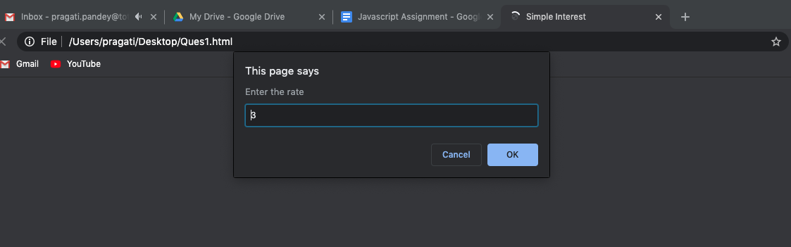

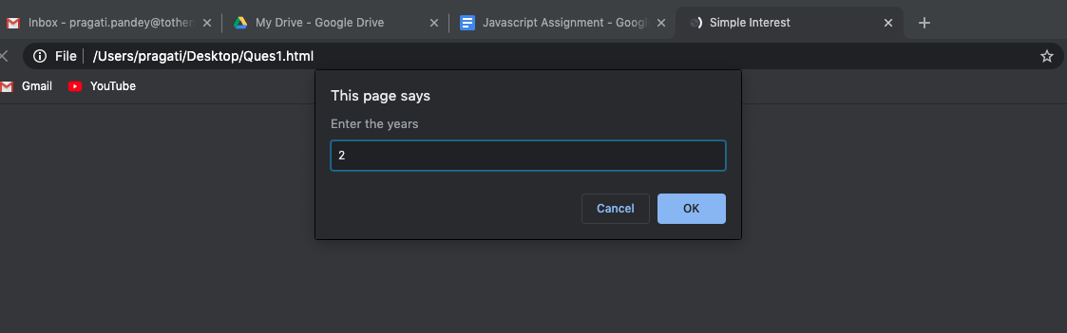

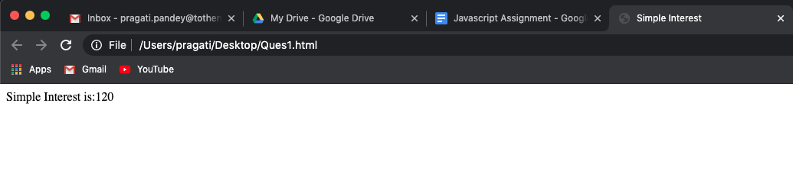

Ques2. is palindrome string.

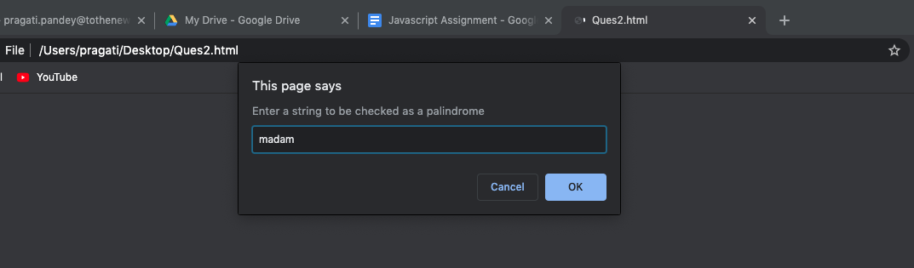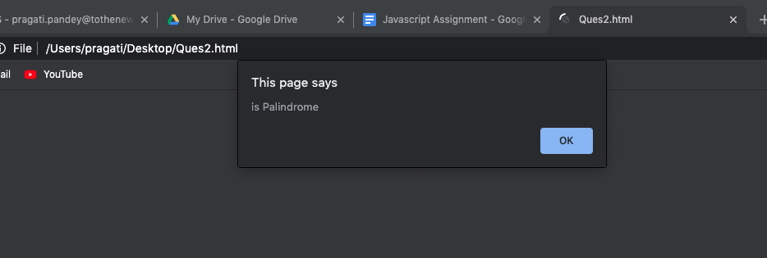

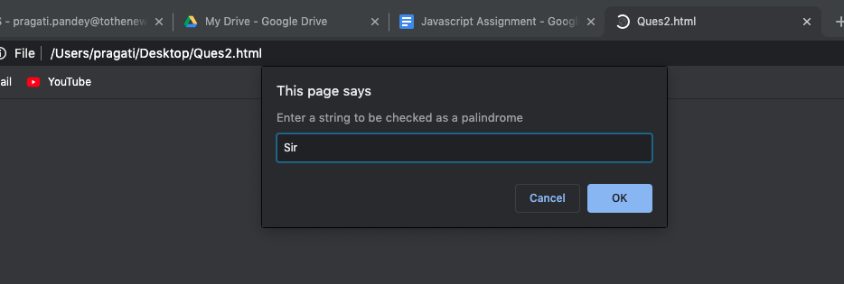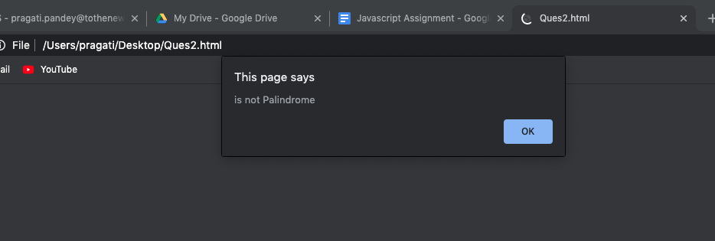

Ques3. Area of circle

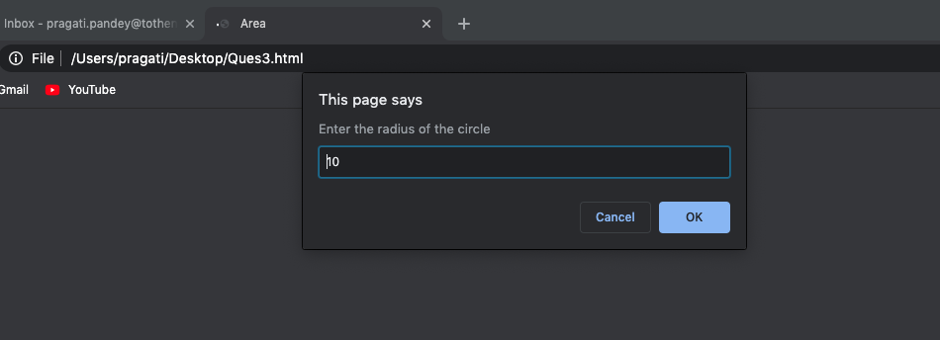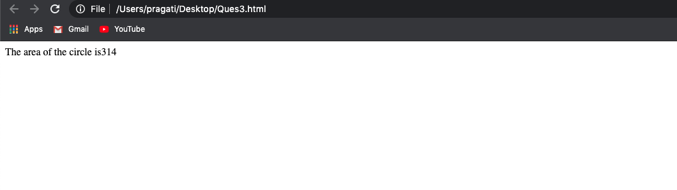

Ques4. Copy information of one object to another and log it to console.

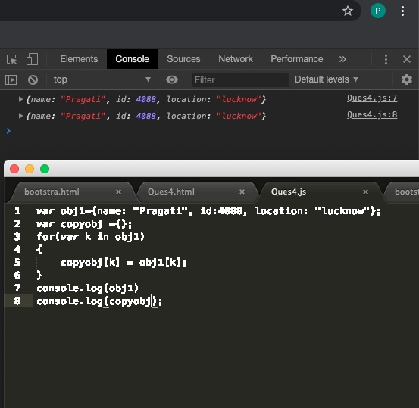

In this obj1 has been copied to copyobj.

Ques5 create a list of objects of Employee with info as follow :

* Name, age, salary ,DOB
* filter all employees with salary greater than 5000
* group employee on the basis of their age
* fetch employees with salary less than 1000 and age greater than 20. Then give them an increment 5 times their salary.

